Waabanong Weekly Update
Delivered June 15, 2026
Week of June 8 to 12, 2026
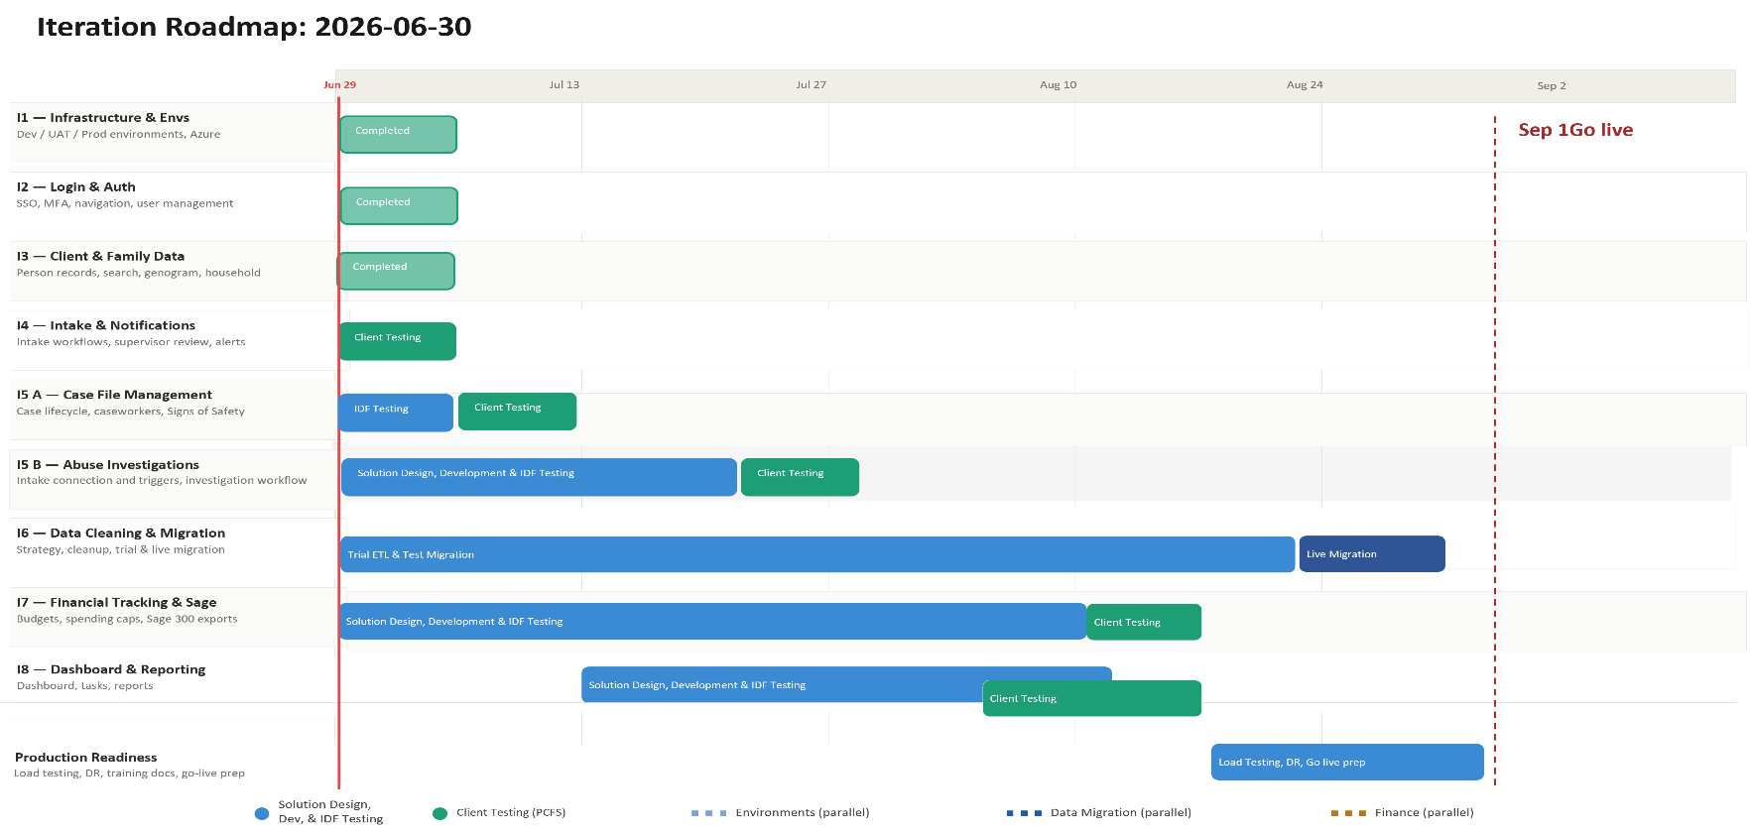

Iteration | Status | Current phase | Notes
I1 - System Infrastructure & Environments | Complete | Maintenance | Permission sync command added; version bump
I2 - Login & Authorization | Complete | Maintenance | No changes this week
I3 - Client, Member & Family Data | Complete | Bug Fix | Log tab built out; genogram fixes
I4 - Intake Management & Automated Notifications | Complete | Bug Fix | Intake/case management tab fixes
I5 A - Case File Management & Signs of Safety | In Progress | Development / Design | Major SOS sprint — steps 4–13 implemented; F2F, AMR, client profile workflow confirmed
I5 B – Abuse Investigations | In Progress | Design | No activity this week
I6 - Data Migration | Not Started | — | No activity this week
I7 - Financial Tracking & Exports for Sage | In Progress | Design | No activity this week
I8 - My Dashboard & Reporting | Not Started | — | No activity this week

Project Management & General
Weekly Progress
- Heavy development week — 50 commits across Jun 10–12, focused almost entirely on the Signs of Safety module and case file infrastructure
- Case file design session held Jun 9 with PCFS ongoing services team (Kelvin, Leanne, Roopanjot, Christina) and Gabrielle/Ross — face-to-face compliance workflow, AMR family visit plans, and client profile document generation confirmed
- Follow-up meeting between Gabrielle and Leanne scheduled for early the following week to review case file wireframes in detail
I1 - System Infrastructure & Environments
Features
- Set up Development, Testing, and Production environments
Weekly Progress
- Permission sync command added to support role-based permission management
- Permission model updates deployed
- Footer version bump
I2 - Login & Authorization
Features
- Microsoft 365–based authentication
- User login
Weekly Progress
- No authentication changes this week.
I3 - Client, Member & Family Data
Features
- Centralized person records (children, adults, limited profiles)
  - Duplicate prevention
- Family and household structures
  - Multi-generation relationships
- Reciprocal relationship logic
- Global search across people and families
Weekly Progress
- Log tab fully built out for person records — activity history now visible from the person view
- Genogram document updates
- Household section: names no longer cut off when too long
- Genogram fix: "Do Not Contact / Other Order" no longer appearing incorrectly in genogram display
I4 - Intake Management & Automated Notifications
Features
- Structured intake workflows with mandatory fields
- Intake status tracking and lifecycle
- Supervisor review and approval processes
- Ability to resolve intake without opening a case
- Escalation from intake to case creation
- Printable intake records
- Automated notifications:
  - In-application alerts
  - Defined external channels (email/messaging)
Weekly Progress
- Intake and Case Management tab fixes — tab working correctly in both view and edit contexts
- Case subtype now hidden when not applicable on new case creation
I5 A - Case File Management & Signs of Safety
Features
- Case file creation and lifecycle management
- Assignment of caseworkers and supervisors
- Case reassignment with approval
- Signs of Safety–aligned workflows, including:
  - Placement
  - Structured assessments
  - Safety goals and planning
  - Ongoing review checkpoints
- Visibility into historical and related cases
- Case notes for visits, services, and interactions
- Communication tracking across intake and case contexts
  - Document management: Person, Intake & Case
Weekly Progress
- Major Signs of Safety (SOS) development sprint this week — steps 4 through 13 implemented:
- SOS tab bar and collapsible section UI completed with step filtering
- Steps 4 and 5: status badge styling and interactions
- Step 6: implemented with UI
- Step 7: UI completed
- Steps 8–12: implemented
- Step 13 — Safety Plan: upload/end logic, migration for new fields, management modals, and UI cards with routes
- Safety Scale box: added to SOS tab; read-only mode corrected for case file tabs
- Supervisor review fully implemented:
- Model, migration, controller submission logic built
- Review history UI with modal JS
- Supervisor review section table alignment and cursor style improved
- Risk Assessment: handling fixes and general upload modals
- Harm Matrix: upload trigger implemented — reverts Risk Assessment status to pending and creates a follow-up task
- SOS task generation and scheduling implemented
- Sharing circles: "Add Circle" functionality working; card layout updated
- Document upload: validation messages and error handling enhanced across SOS steps
- "Practice Rehearsals" renamed to "Practice of Rules" in document type seeder
- Case file log tab added — activity history visible from the case file
- Case file existence check added in log tab to handle create mode correctly
- **Jun 9 design session** — face-to-face compliance workflow, AMR family visit plans, and client profile generation confirmed with PCFS ongoing services team:
- **Face-to-face (F2F) visit logging:** workers log visit date, who conducted it, location, one-on-one status, and upload the signed F2F form (caregiver, child, worker, and supervisor signatures required); list is filterable by visit type
- **F2F compliance deadlines:** children in care must be seen by the 20th of each month, with a hard deadline on the business day before the last Monday of the month; system triggers high-priority alerts for overdue visits
- **Override permissions:** supervisors, CRDs, and admin (including Kelvin) can override default visit frequency pathway; override is logged with a mandatory reason; customer care agreements may require less frequent visits and system must accommodate CRD pathway adjustments
- **Visit conductor selection:** system captures the actual person who conducted the visit (not just role); case aides may conduct visits but lack system access — the responsible worker uploads documentation
- **Case note deadline:** workers have five days after a visit to submit case notes; system triggers reminders if notes are missing; freeform text entry, document upload optional
- **Collateral F2F workflow:** when a visit is overdue, worker can request a collateral visit — triggers a 24-hour supervisor approval task; CRDs can reassign if supervisor is unavailable; collateral form requires worker and supervisor signatures; if signature cannot be obtained, a checkbox + reason field triggers CRD approval for the exception
- **AMR family visit plans:** visitation schedules created with frequency, duration, location, and authorized participants; agency-generated schedules uploaded as documents (system-generated schedules may not cover all scenarios); plan versioning tracks history, reasons for updates, and associated signed documents; individual visitations logged with schedule, date, duration, location, supervising staff, and present family members
- **No Contact Orders (NCOs):** any NCO involving anyone in the child's genogram or family group displayed prominently on the case file and child's profile
- **Client profile document generation:** Leanne to provide youth profile and annual assessment templates; system generates PDF for case transfers and new placements; document is printed only — not emailed or shared electronically; each generation is logged (user + timestamp) for privacy compliance
- **Task automation:** system-triggered tasks (overdue visits, missing notes) can auto-assign or allow worker to select due date and assignee; temporary worker assignment flagged for a future release
- Wireframes and triggered-task Excel document to be distributed by Gabrielle for team review; Leanne to provide dropdown field values for AMR visit frequency and location
I5 B – Abuse Investigations
Features
- Triggers and integration with Intake module
- Investigation workflow
- Investigation document management

Weekly Progress
- No additional external review this week; Abuse Investigations remains in solution design, incorporating PCFS workflows.

I6 - Data Cleaning and Migration
Features
- Develop a data migration strategy from FAMCare into Waabanong
- Support PCFS as they perform data cleanup
- Execute trial data migrations in a sandbox environment
- Perform live data migration
Weekly Progress
- Data migration planning continues with Campfire, focusing on secure access, privacy, and approach for trial migrations.

I7 - Financial Tracking & Exports for Sage
Features (Potential scope may include)
- Intake-level emergency supports
- Case-level budgets
- Spending caps and approvals
- Export files to import into Sage 300
Weekly Progress
- Finance work remains queued for the next working session; no new finance work this week.

I8 - My Dashboard & Reporting
Features (Potential scope may include)
- My Dashboard (simple, quick reference to key items)
- Tasks & alerts
- Reporting (if required and not covered in other iterations)
Weekly Progress
- Future iteration per schedule (no dashboard/reporting work this week).

